Adding DenseLayers

|  |  |
| --- | --- |
| Date | 24 November2022 |
| TeamID | PNT2022TMID43214 |
| Project Name | AI-powered Nutrition Analyzer forFitnessEnthusiasts |

Adenselayerisadeeplyconnectedneuralnetworklayer.Itisthemostcommonandfrequentlyusedlayer.

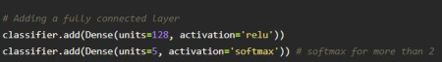

ThenumberofneuronsintheDenselayeristhesameasthenumberofclasses in the training set. The neurons in the last Dense layer, usesoftmaxactivationtoconverttheiroutputsintorespectiveprobabilities.

Understandingthe model is avery important phase toproperly using it

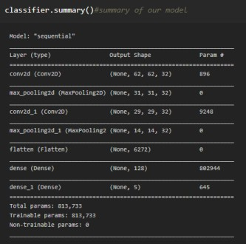

for training and prediction purposes. Keras provides a simplemethod, a summary to get the full information about the model anditslayers.